# PROJECT REPORT TEMPLATE

# INTRODUCATION

## 1.1, OVERVIEW

The banking industry world-wide is being transformed. The global forces for change include technological

innovation; the deregulation of financial services at the national level and opening-up to international

competition; and - equally important - changes in corporate behavior, such as growing disintermediation and

increased emphasis on shareholder value. In addition, recent banking crises in Asia and Latin America have

accentuated these pressures. The banking industries in central Europe and Latin America have also been

transformed as a result of privatizations of state-owned banks that had dominated their banking systems in

the past. In this project we are trying to analysis the bank related data and able to extract some insights from

the data using Business Intelligence tools. To Extract the Insights from the data and put the data in the form of

visualizations, Dashboards and Story we employed Tableau tool.

## 1.2 purpose

ndustrial and Commerical activity account for more

than . Homes account for a fourth, while

agriculture has accounted for over a sixth in recent year

# PROBLEM DEFINITION &DESIGN THINKIN

## EMAPATHY MAP

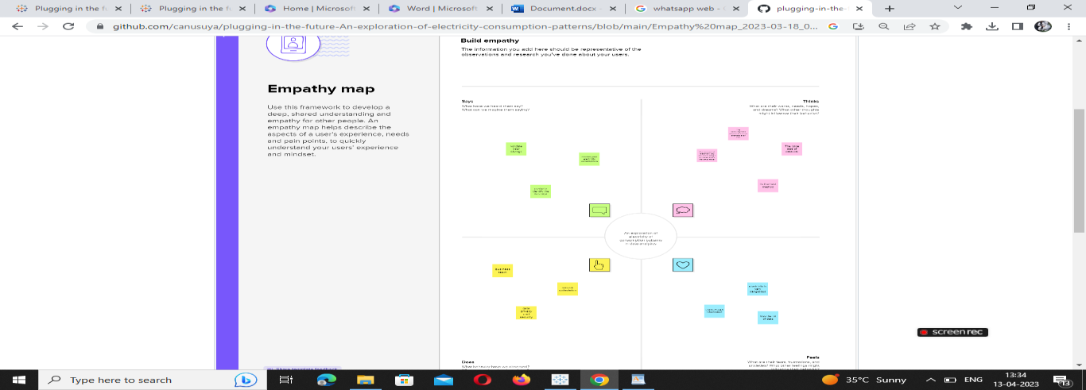

## BRAINSTORMING &IDEATION MADE

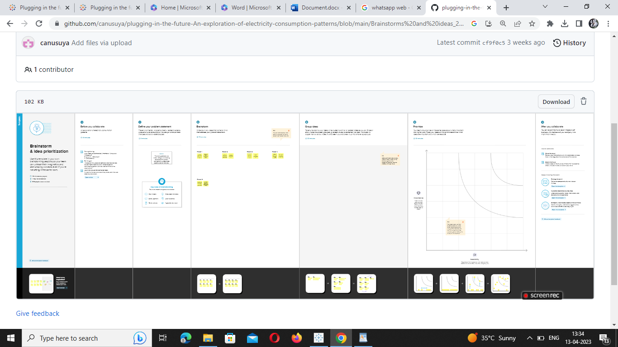

# VISULIZATION,DASHBORAD AND STORY

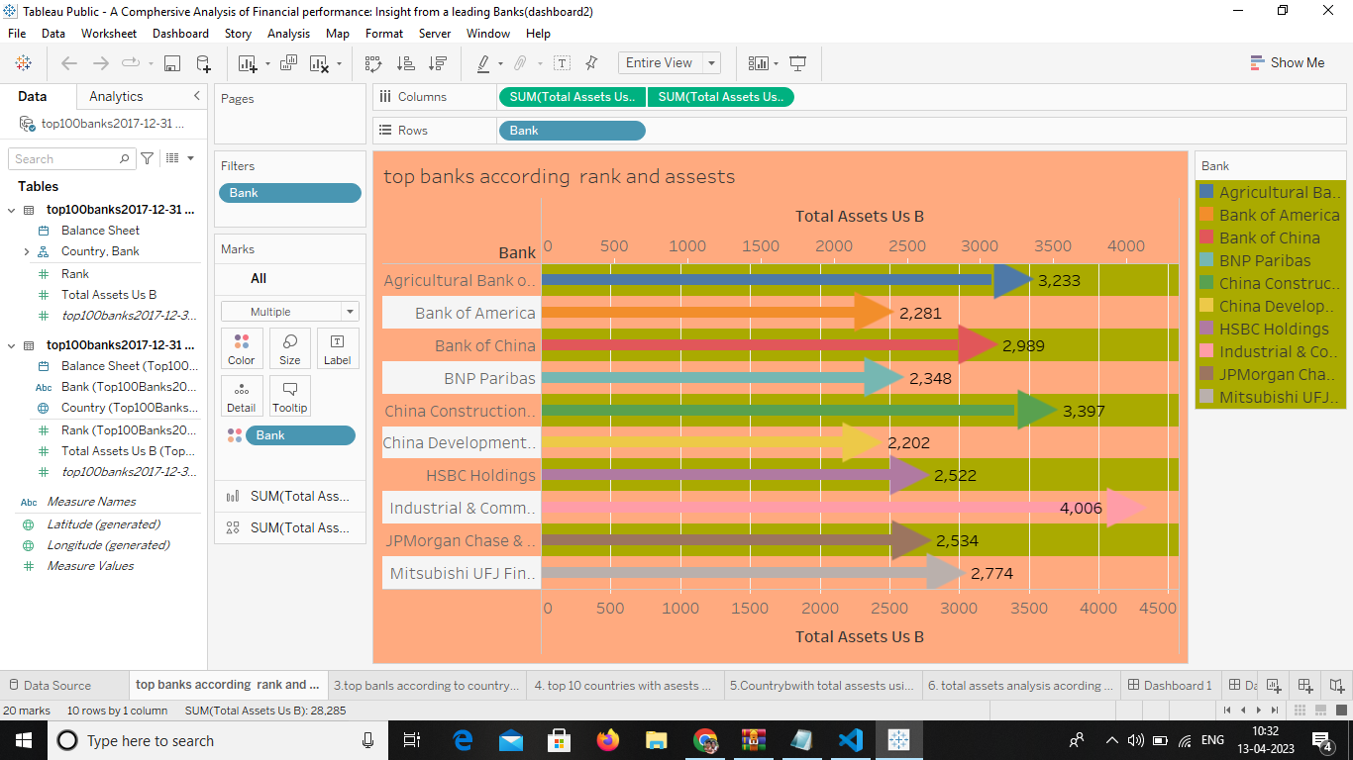

2

## 3.2 TOP BANKS ACCORDING TO TOTAL ASSETS

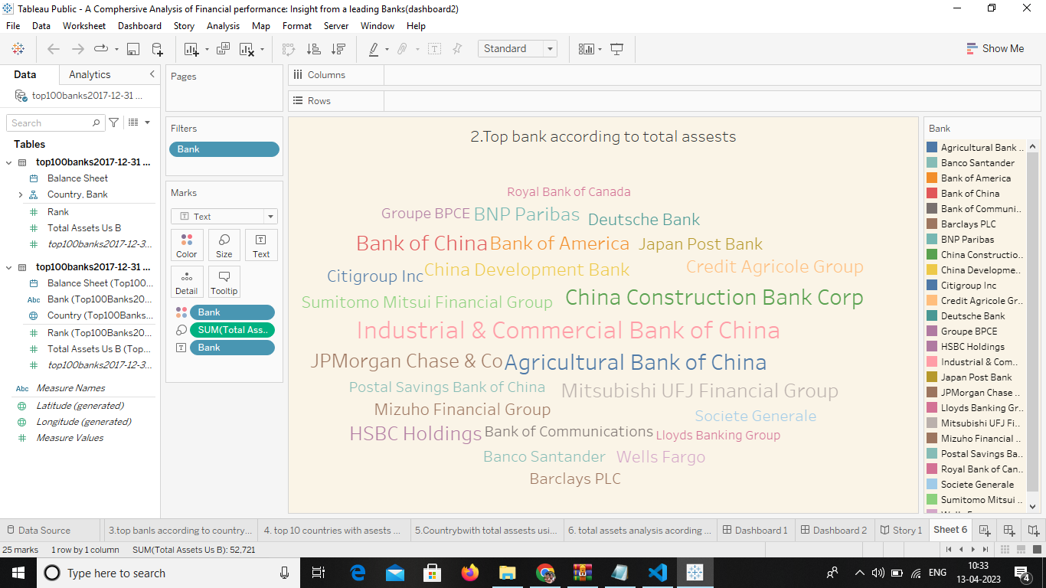

## 3.3 TOP BANKS ACCORDING TO COUNTRY BASED ON TOTAL ASSEST

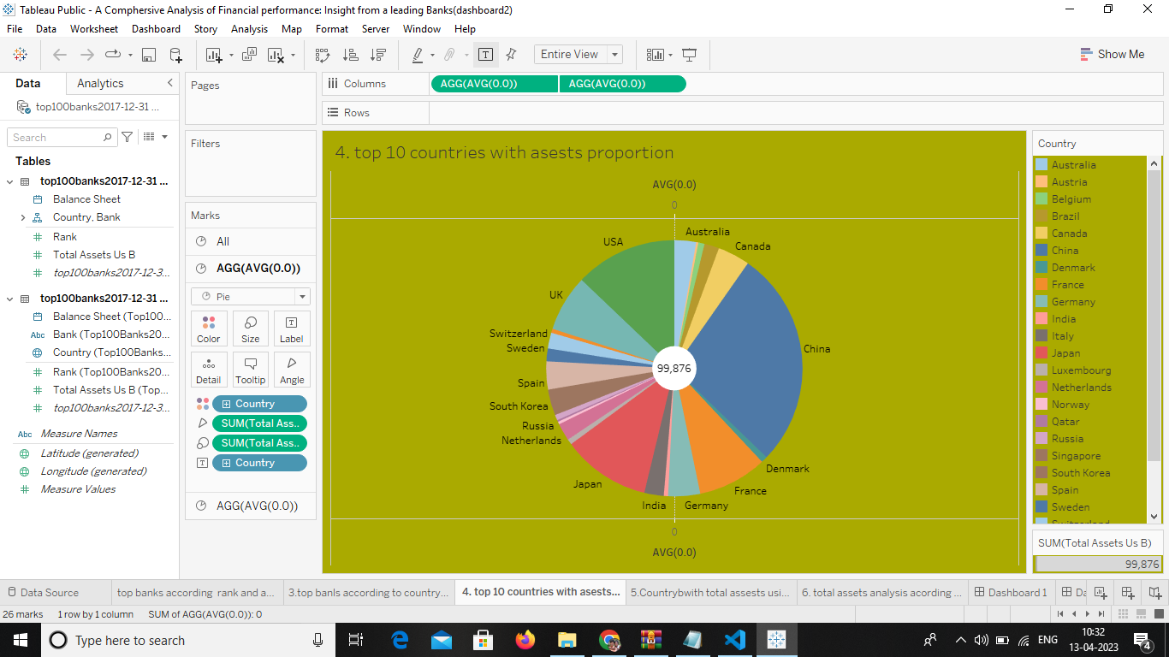

## 3.4 TOP 10 COUNRIES WITH TOTAL ASSETS USING FUNNEL CHARTS IN INCREASING ORDER

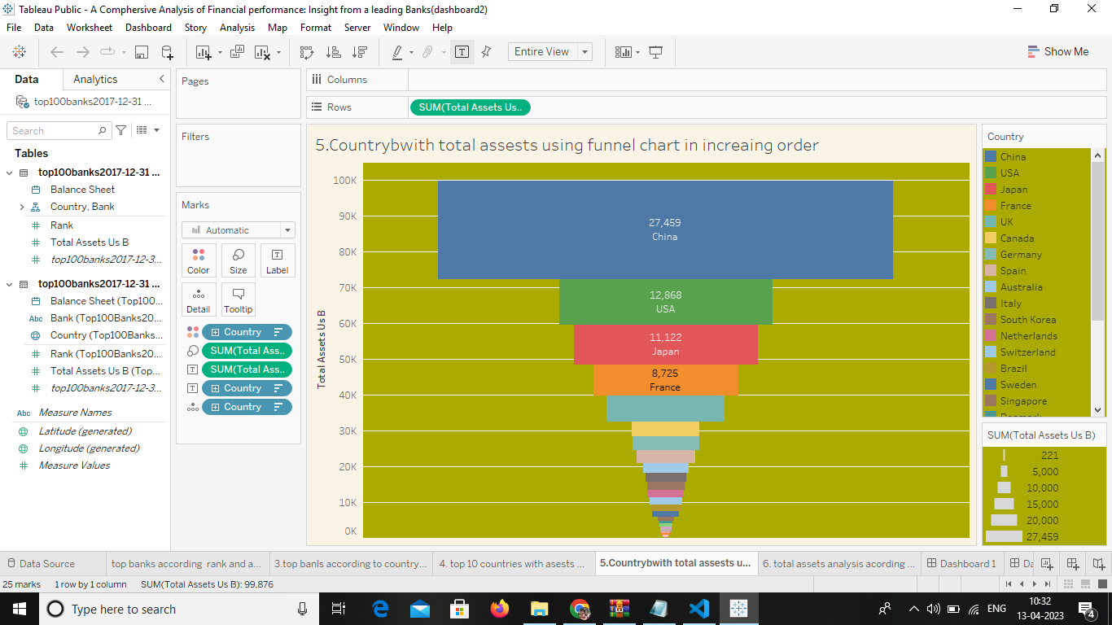

## 3.5 TOP BANKSACCORDING TO TOTAL ASSETDS

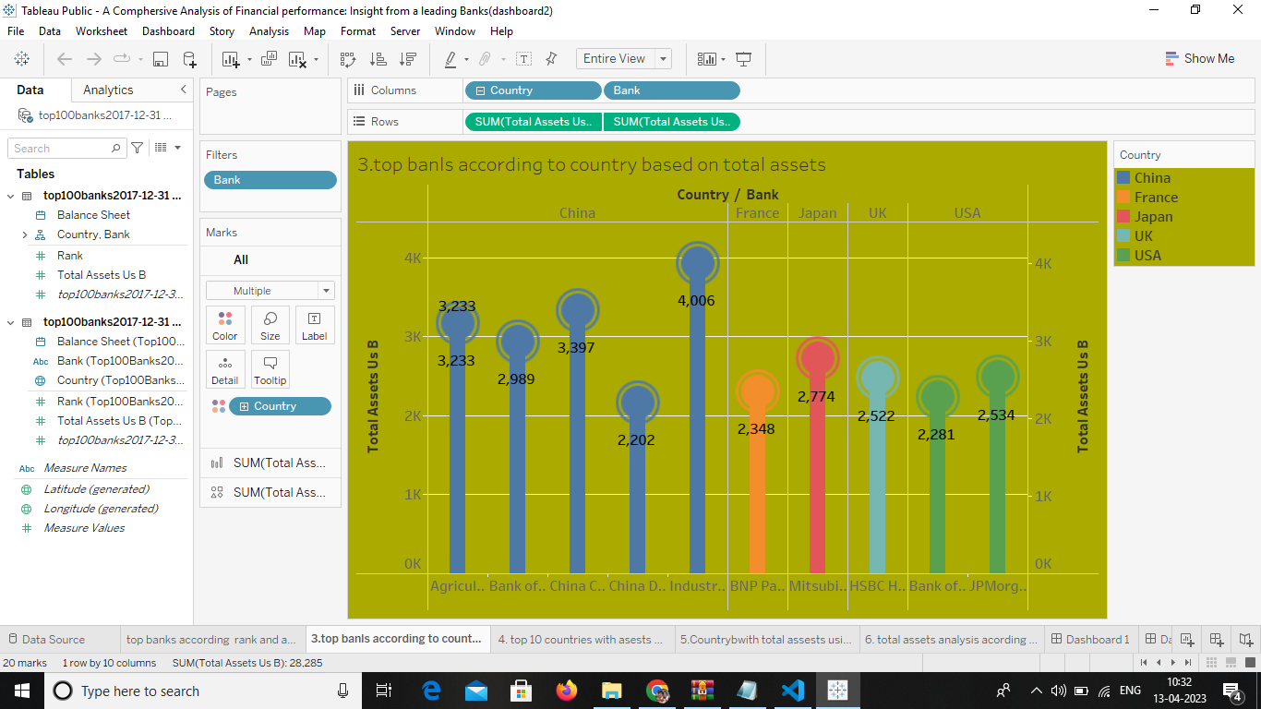

## 3.6 TOTAL ASSETS ANALYSIS ACCORDING TO YEAR AND QUARTZ

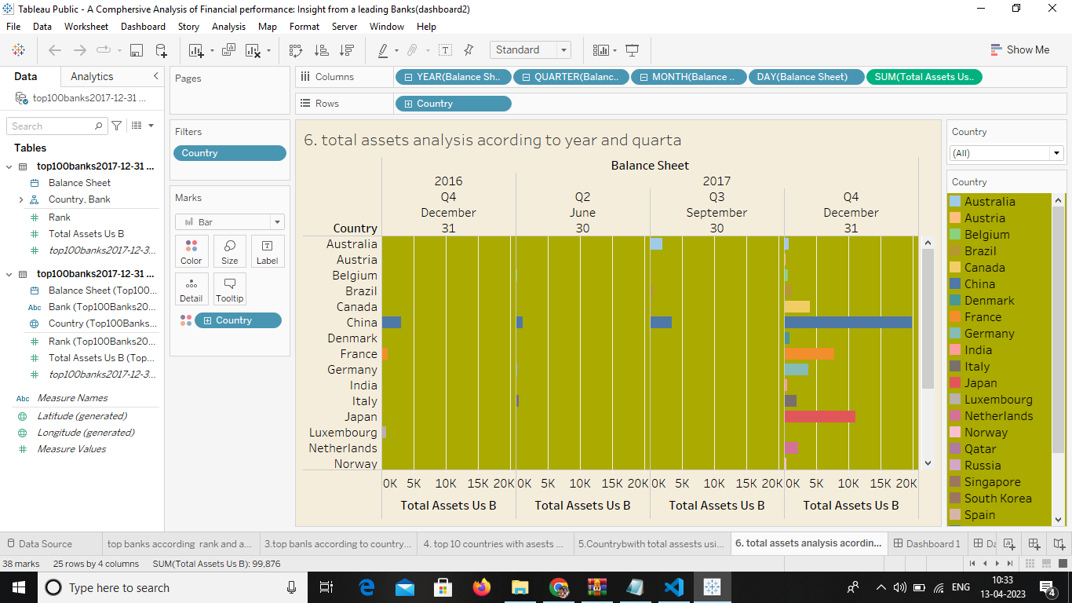

# 4.1 ADVANTAGE

A **comprehensive** **review** of the existing empirical literature on state regulation … **banking**  
**result** in higher costs. The literature on cost **adva**

**ntages** of size (economies of scale) in **banking**

## 4.2 DISADAVANTAGE

**Measurement problems and a short-term concentration** are two drawbacks of financial performance measurements.

Financial statements are the outcome of recorded facts, accounting concepts and conventions used and personal judgments, made in different situations by the accountants. Hence, bias may be observed in the results, and the financial position depicted in financial statements may not be realistic.

## APPLICATIN

1. Gross and net non-performing assets. .
2. Provision coverage ratio.
3. Capital adequacy ratio (CAR) It is the measure of a bank's available capital divided by the loans (assessed in terms of their risk) given by the bank. ...
4. Net interest margin. …
5. Cost to income.

# ENDING……..